**PRACTICAL - 4**

**AIM:** Demonstrate the Dynamic routing configuration using RIP and OSPF protocol using cisco packet tracer

**THEORY:**

**DYNAMIC ROUTING**

* **It is a networking technique that provides optimal data routing. Unlike static routing, dynamic routing enables routers to select paths according to real-time logical network layout changes.**
* **Dynamic routing uses multiple algorithms and protocols. The most popular are Routing Information Protocol (RIP) and Open Shortest Path First (OSPF).**
* **Dynamic routing protocols allow routers to share information about the network with other routers to allow them to select the best path to reach a destination.**

**RIP:**

* **Routing Information Protocol version 2 (RIPv2) is an old routing protocol.**
* **RIPv2 suffers from scalability issues due to a relatively low maximum hop count of 15 routing devices.**

**OSPF:**

* **OSPF is the dynamic routing protocol used in large to very large IP networks.**
* **The protocol uses a link-state database and link-state advertisements to map the network topology.**

**Advantages of Dynamic Routing:**

* **Allows the exchange of routing information whenever the network experiences a change in topology.**
* **Since the routes do not have to be configured manually, there is less administrative overhead.**
* **Less error-prone than static routing.**
* **Allows scalability since there is less administrative overhead involved.**

**CONFIGURATION USING RIPv2**

**TOPOLOGY:**

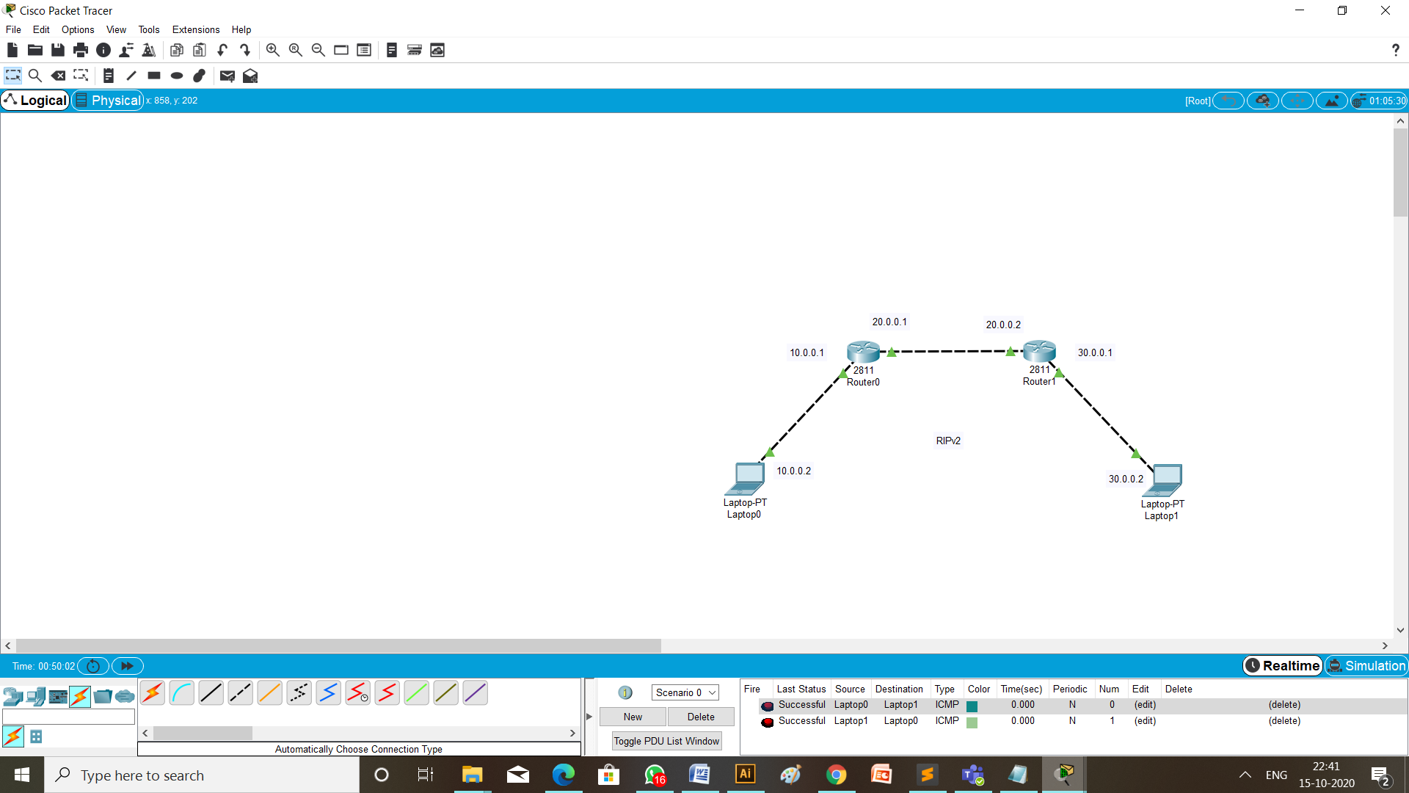

**STEPS OF CONFIGURATION**

1. **First of all to create a topology, click on the device and drop on workplace and connect all the devices with the necessary cables.**
2. **Then configure all the router using CLI and give the ip address as mention in the topology diagram.**
3. Router 1: fa0/0 10.0.0.1

fa0/1 20.0.0.1

1. Router 2: fa0/0 20.0.0.2

fa0/1 30.0.0.1

1. **Provide ip address and default gateway to the laptops.**
2. Laptop 1: ip address is 10.0.0.2

default gateway is 10.0.0.1

1. Laptop 2: ip address is 30.0.0.2

default gateway is 30.0.0.1

1. **Configuration of RIPv2 on router 0 and router 1 are respectively,**

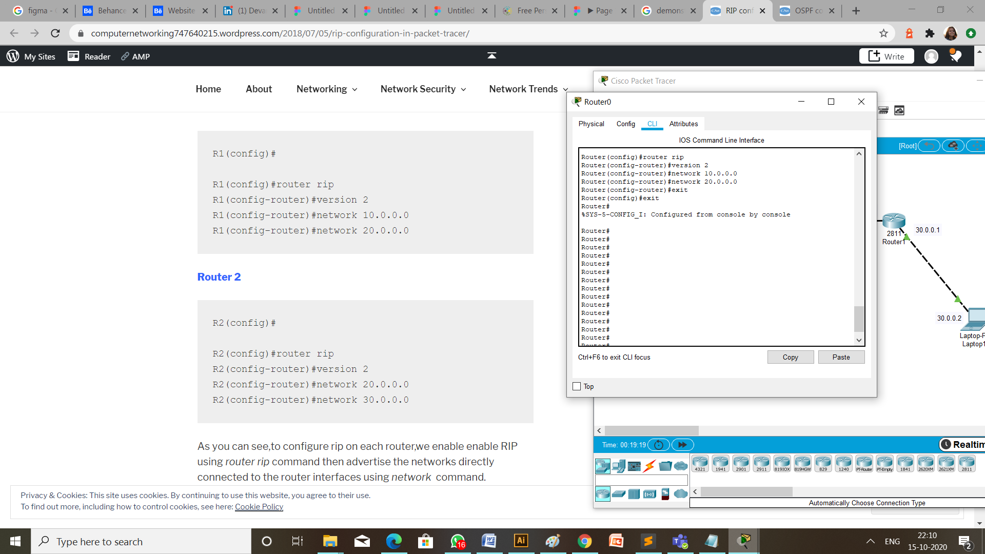

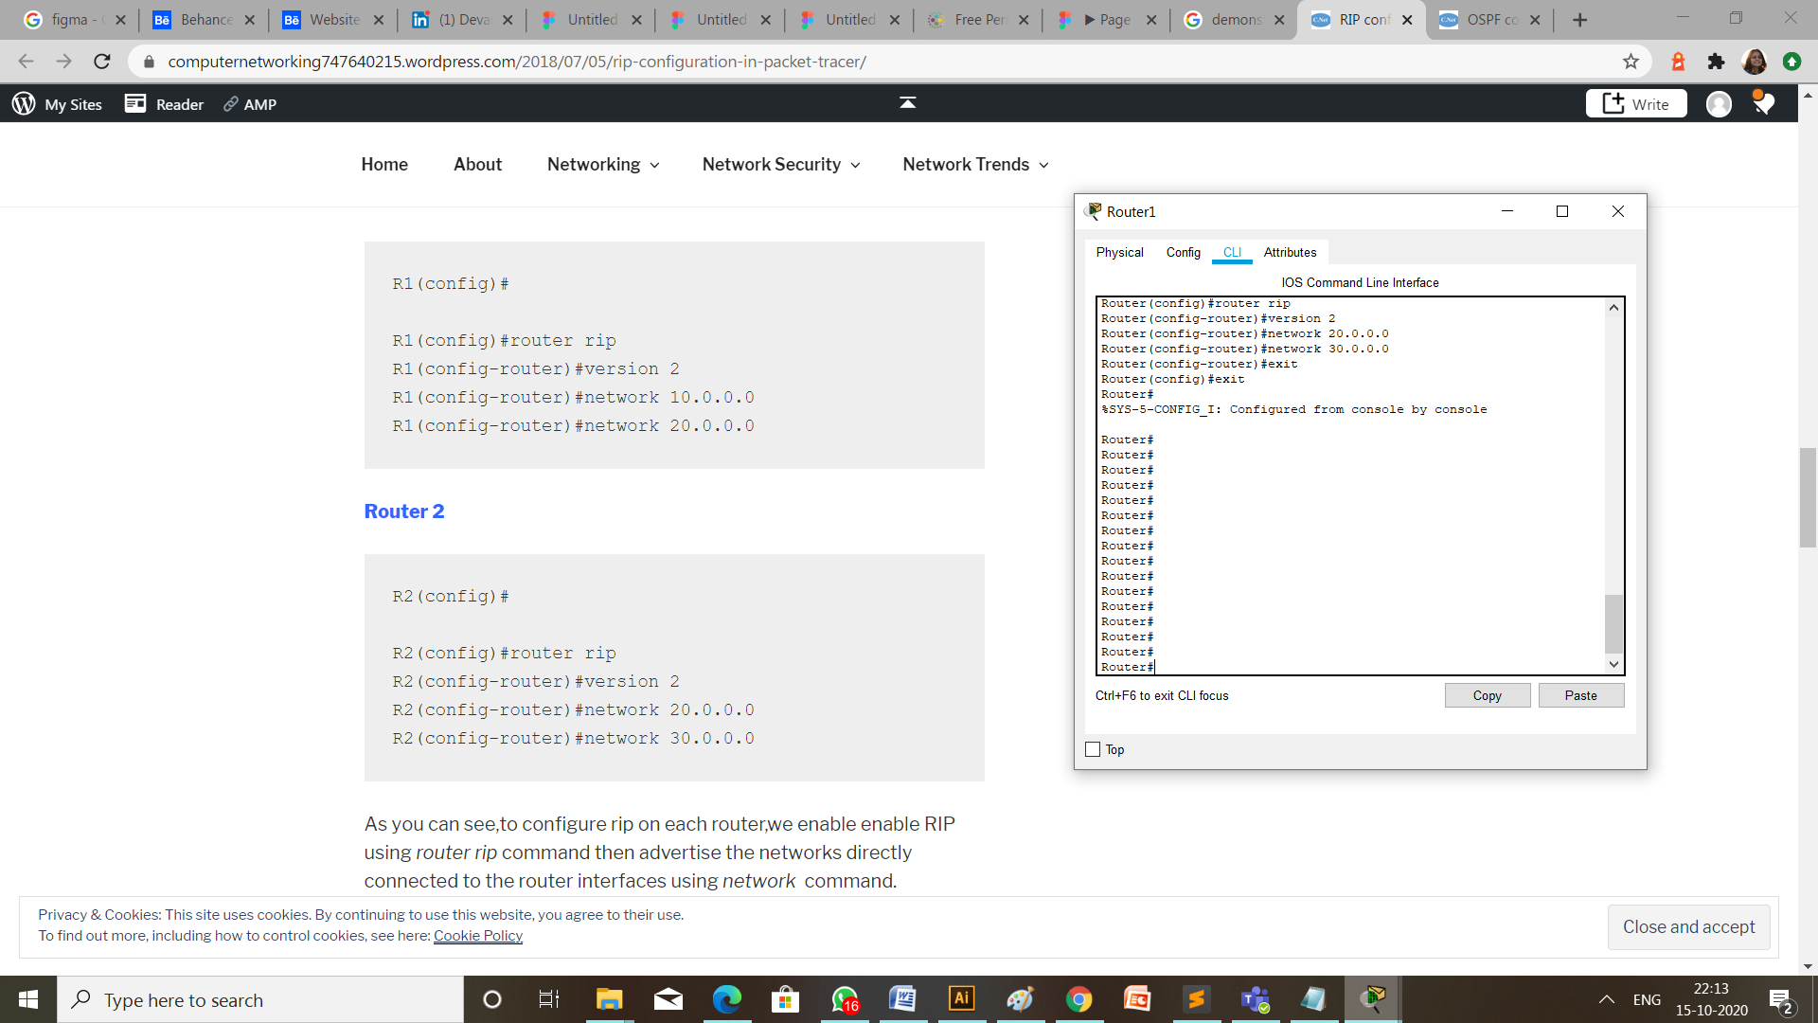

1. **Verify RIP configuration.**

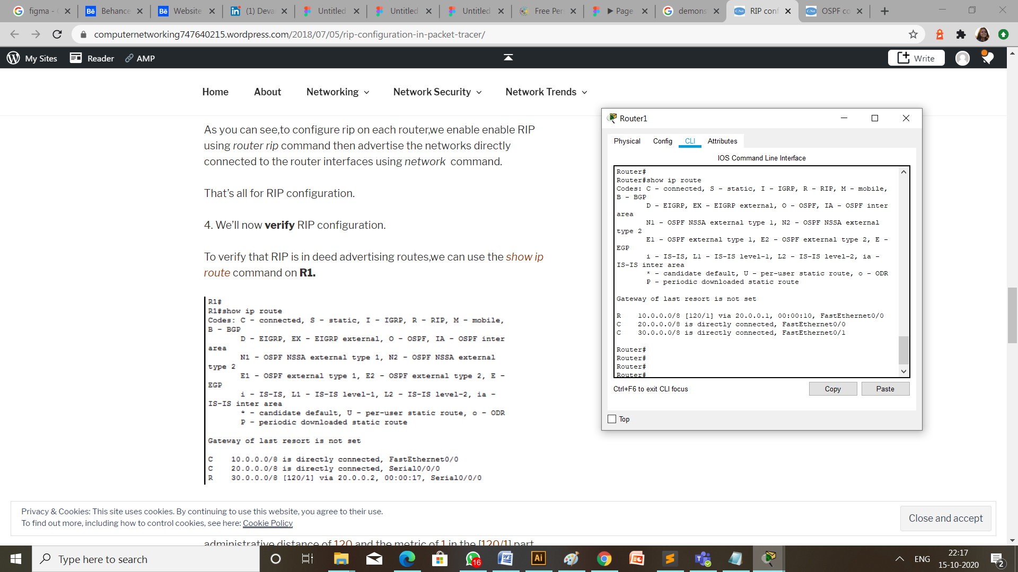

**CHECK NETWORK TOPOLOGY**

We can check if the connection is working properly by two ways:

1. **MESSAGE PASSING**

To check the connections are working properly or not drop one package on a Laptop 0 and receive it from the Laptop 1.



1. **USING PING COMMAND**

Write a command ping 10.0.0.2 (ip address of the destination Laptop) from the command prompt of Laptop having ip address 30.0.0.2 (the source Laptop).

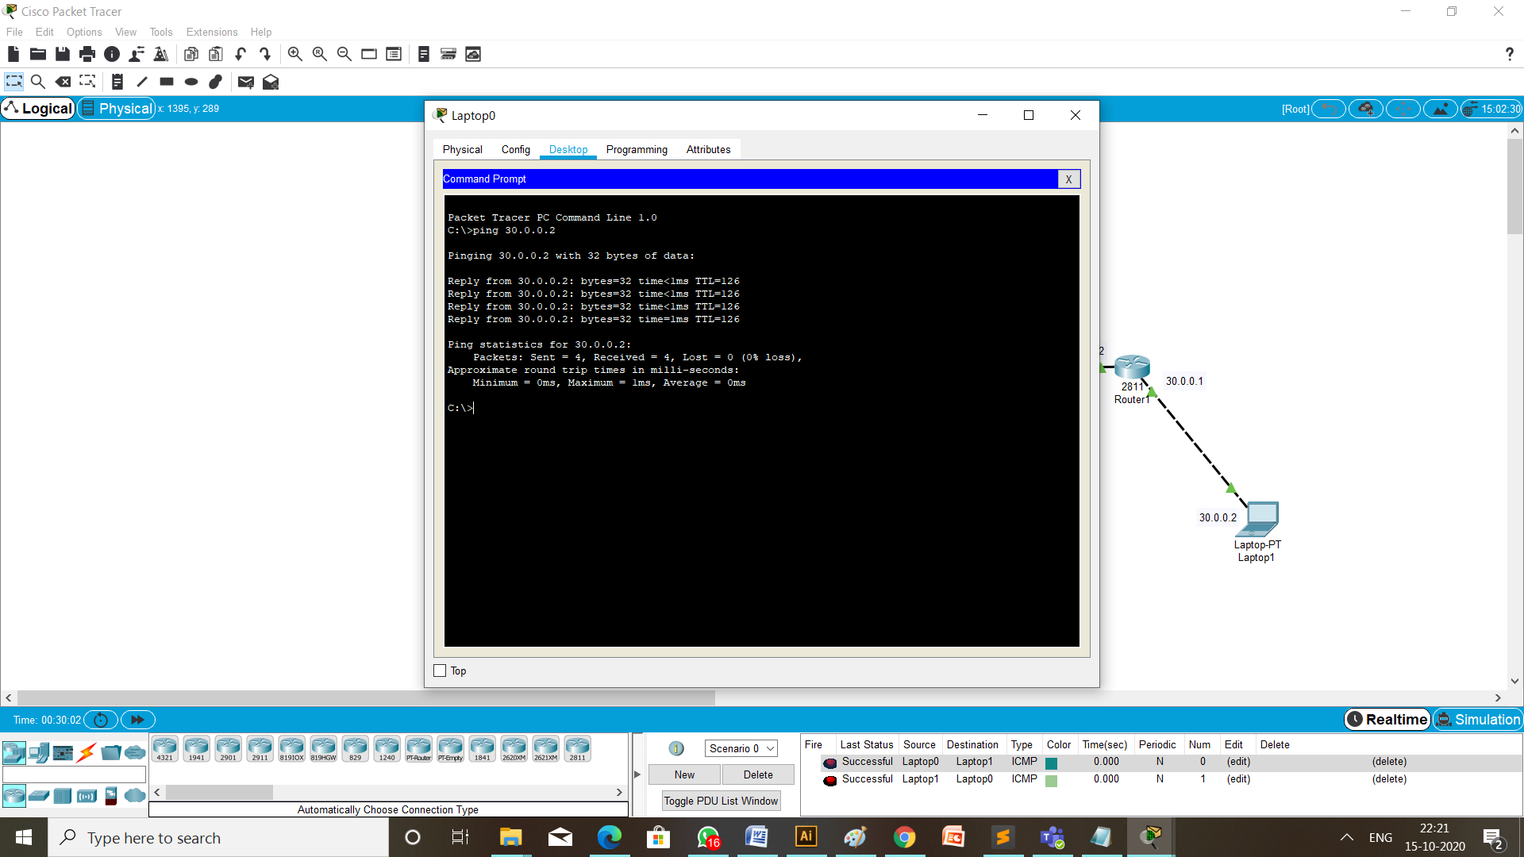

**CONFIGURATION USING RIPv2**

**TOPOLOGY:**

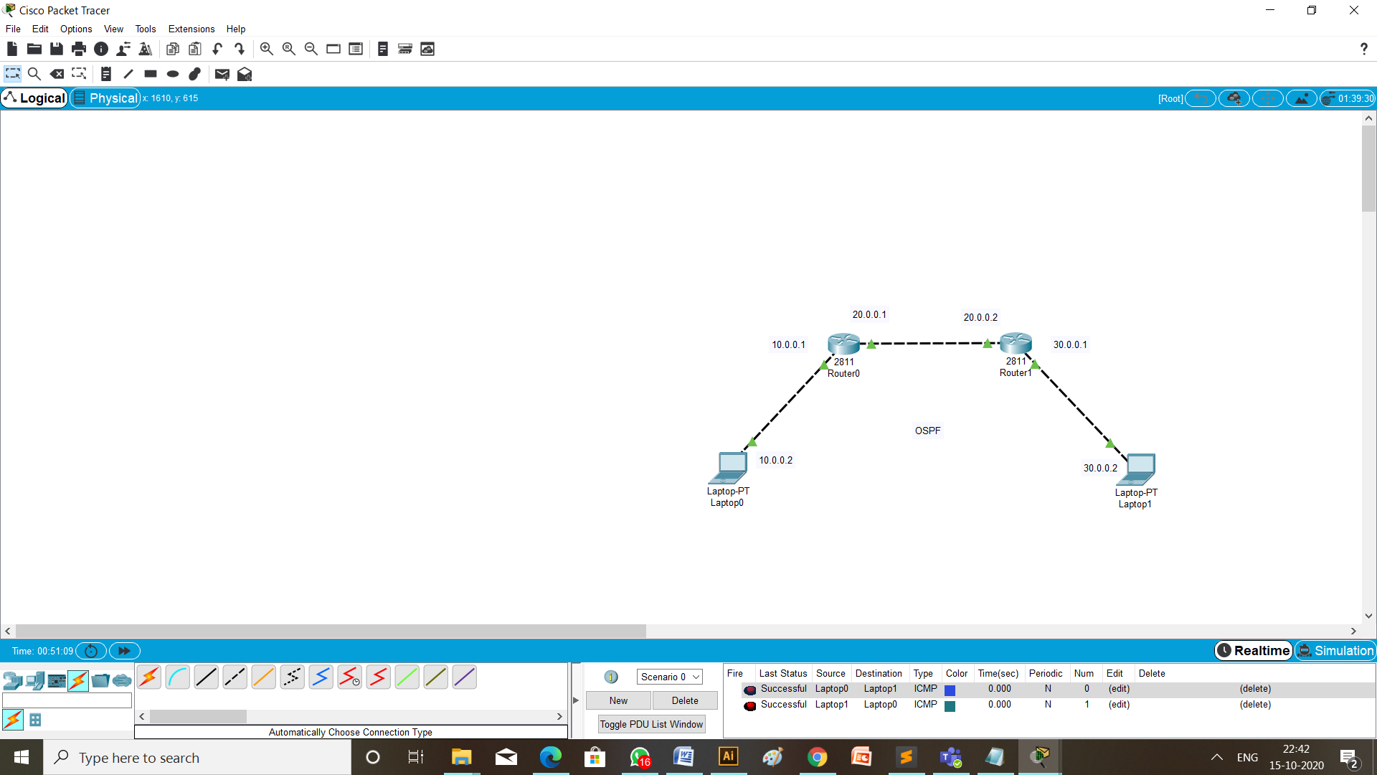

**STEPS OF CONFIGURATION**

1. **Configuration of OSPF on router 0 and router 1 are respectively,**

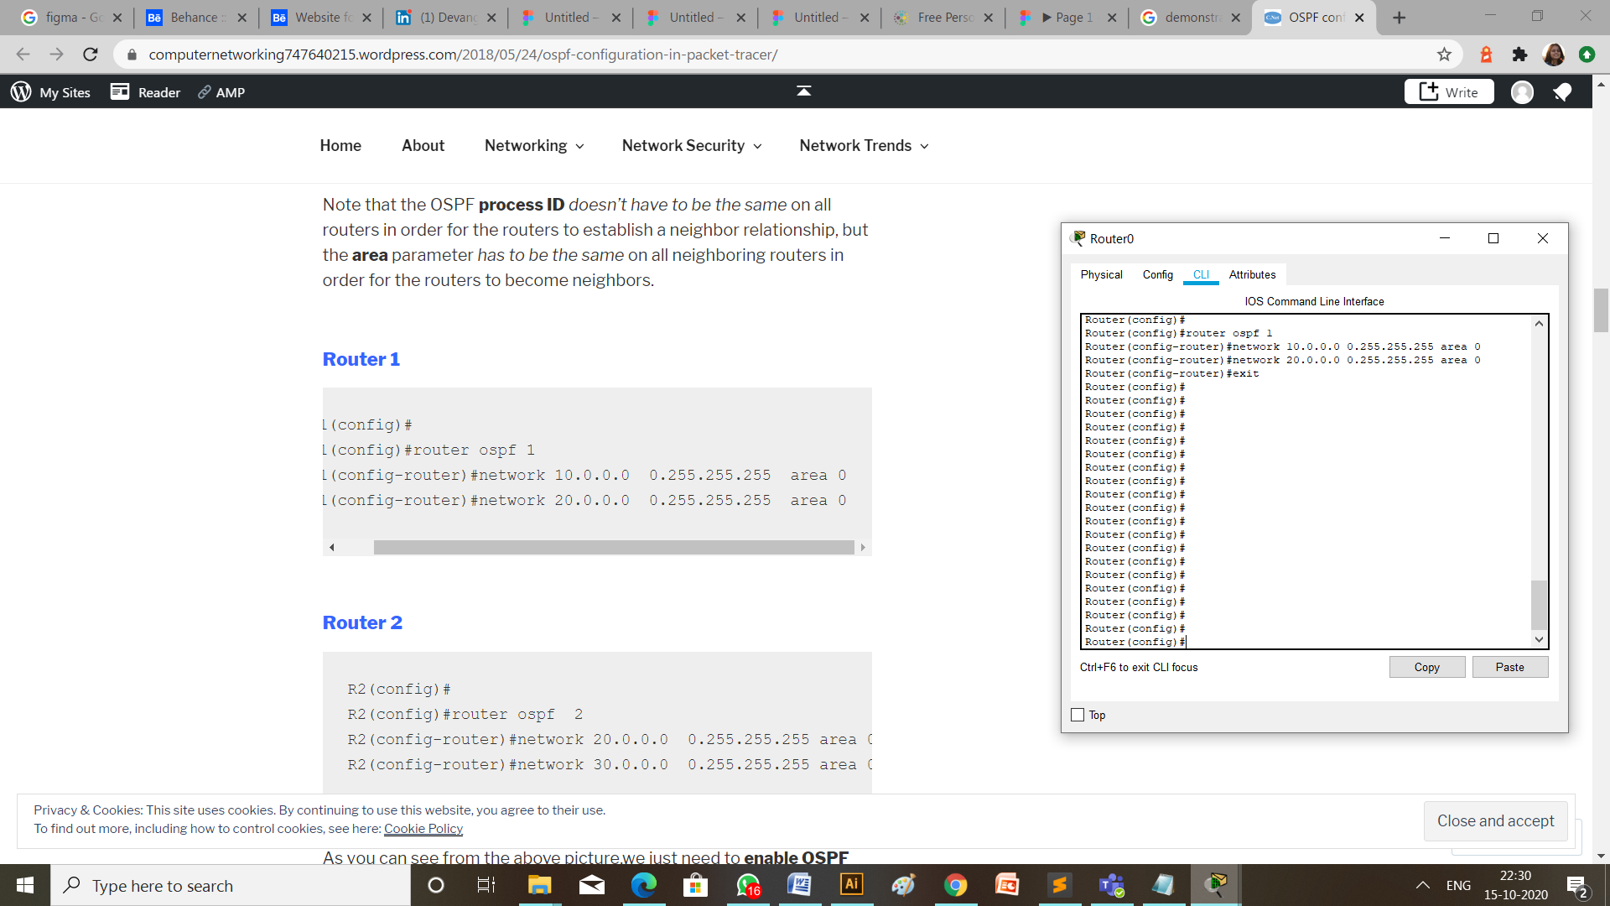

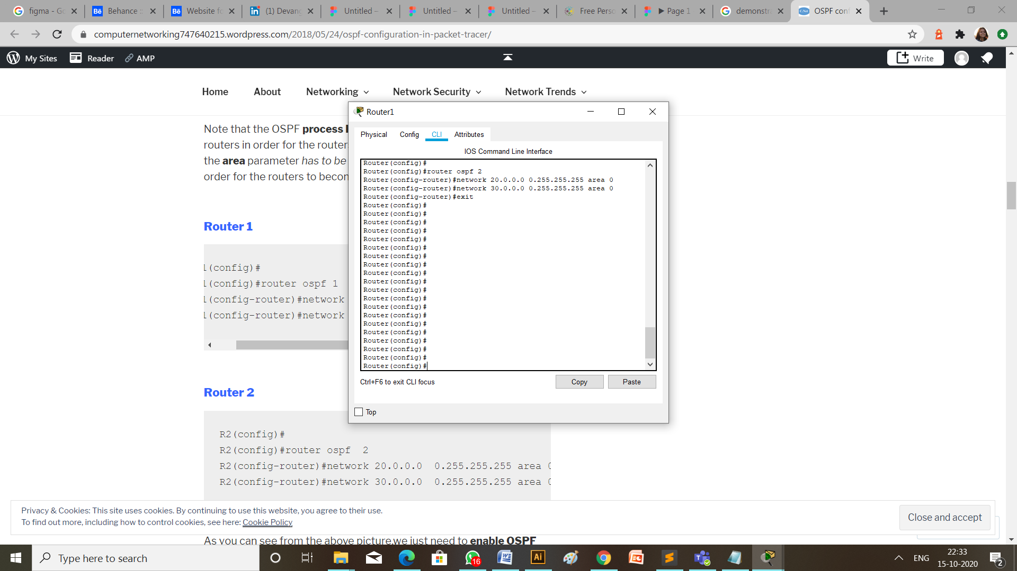

1. **Verify OSPF configuration.**

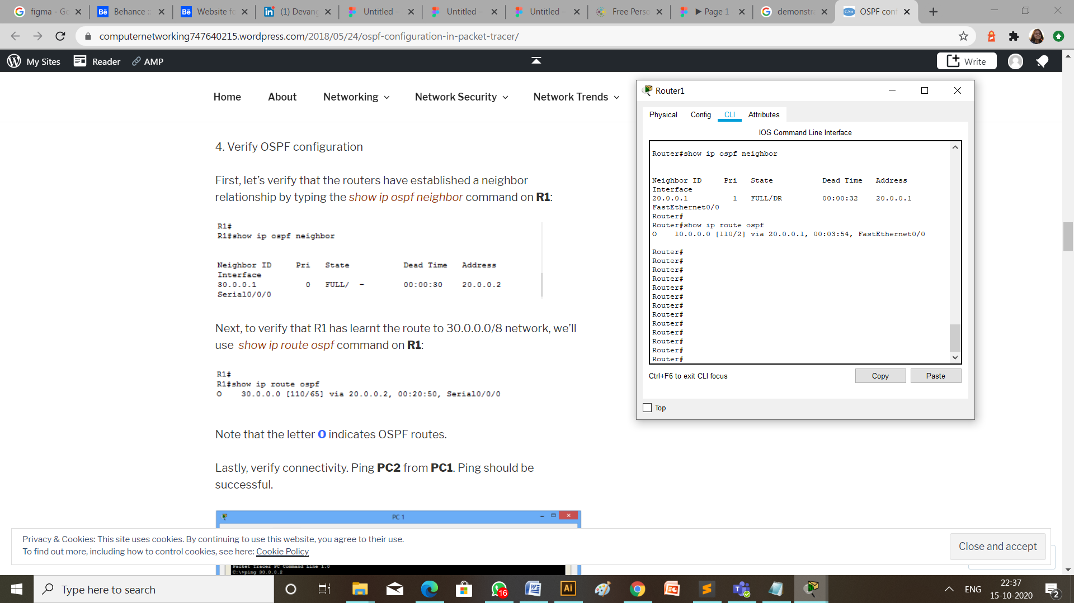

**CHECK NETWORK TOPOLOGY**

1. **MESSAGE PASSING**

To check the connections are working properly or not drop one package on a Laptop 1 and receive it from the Laptop 0.



1. **USING PING COMMAND**

Write a command ping 30.0.0.2 (ip address of the destination Laptop) from the command prompt of Laptop having ip address 10.0.0.2 (the source Laptop).

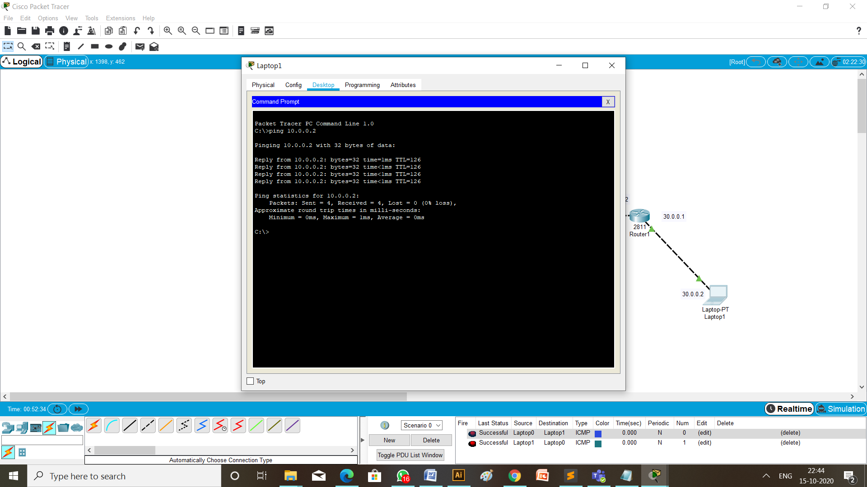

**CONCLUSION:**

Through this practical I learned about how to configure dynamic routing of routers using RIPv2 and OSPF protocol in different networks.